1. **Accessing Onboarding**
   1. Simply open HR Self Service, click on Main Menu then BCBS Onboarding. The system takes a minute to generate.

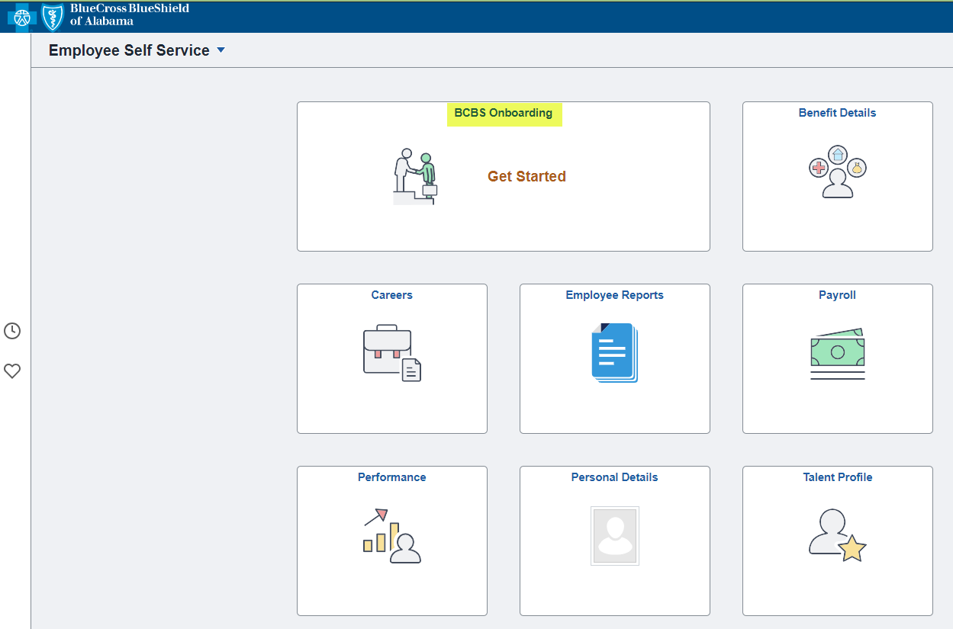 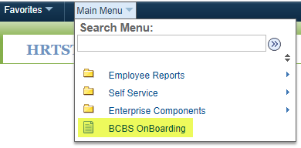

* 1. A new page will open and they will click the “start” button.  
     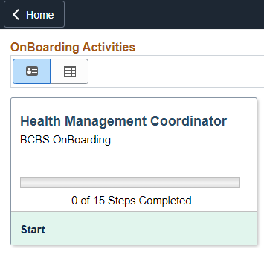

1. **Welcome**  
   A new page will open up with a benefit video for the employee to watch or they can click the “Next” button.

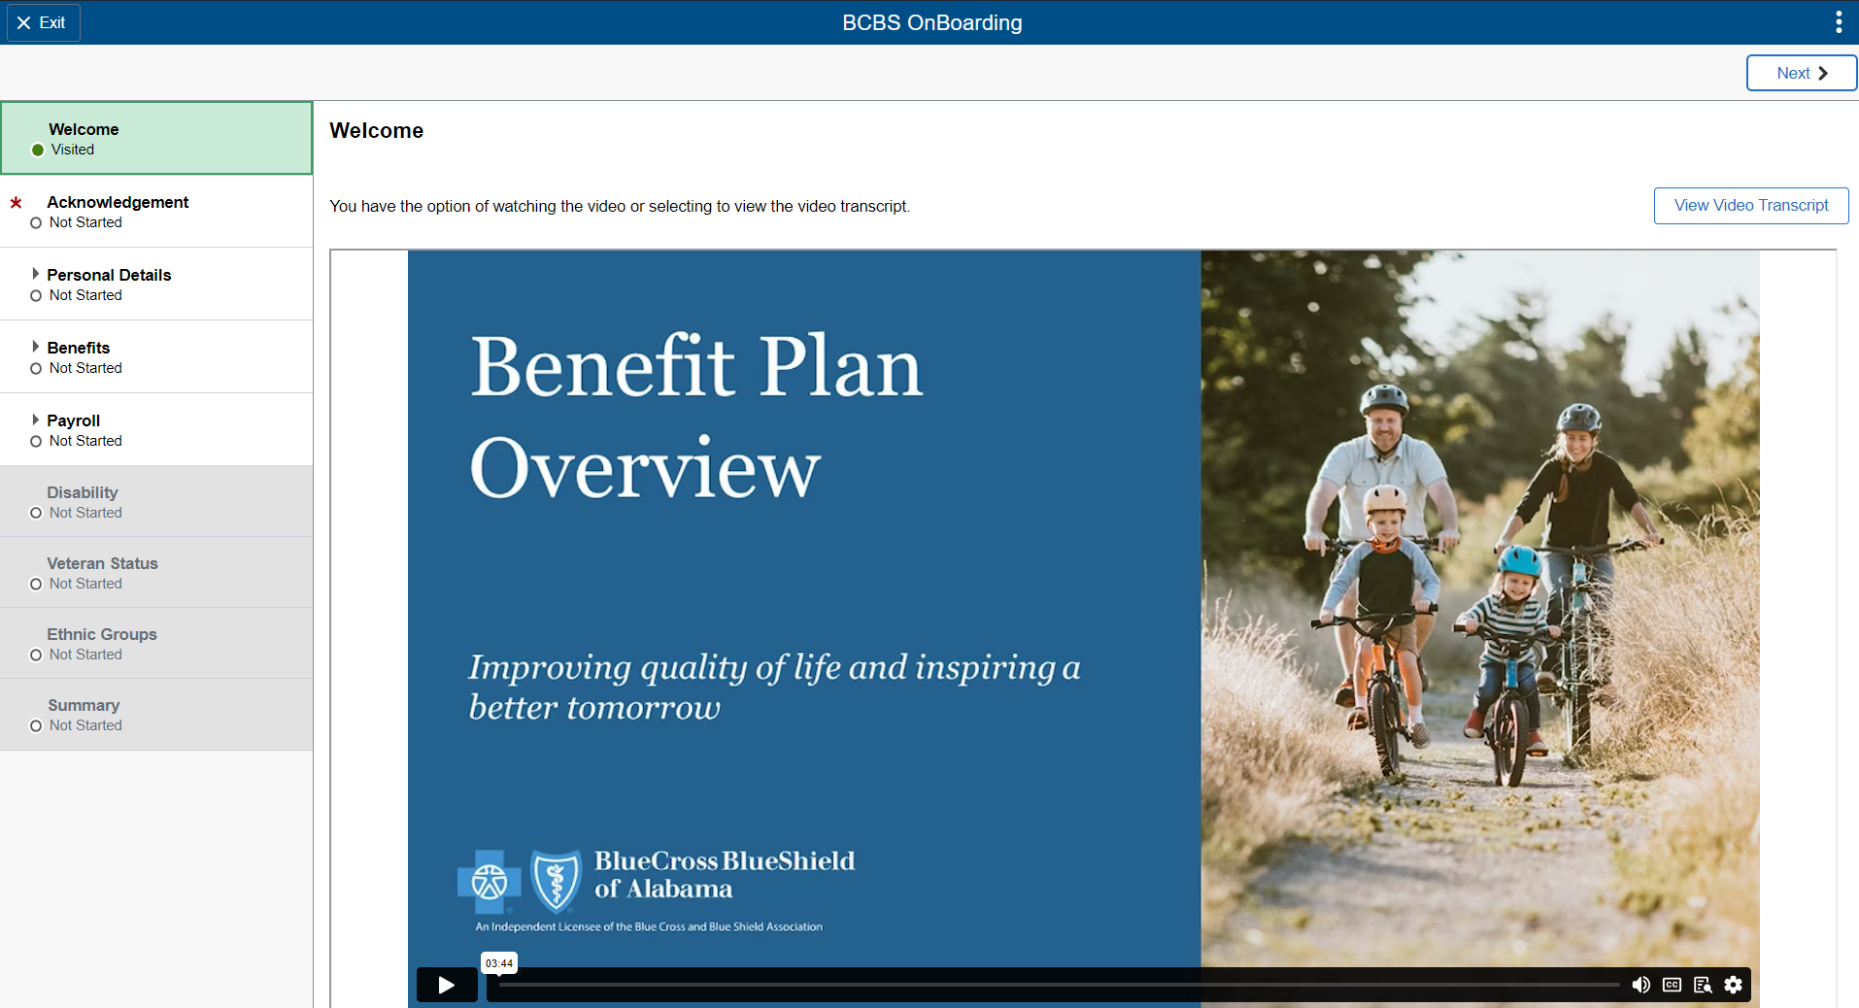

1. **Acknowledgement**

All tabs are locked until the employee agrees to the acknowledgement of the Company Policies. Once they have checked the box and clicked “Save” the reamining tabs will open. They cannot move forward without completing this page. Possible error messages are listed below.   
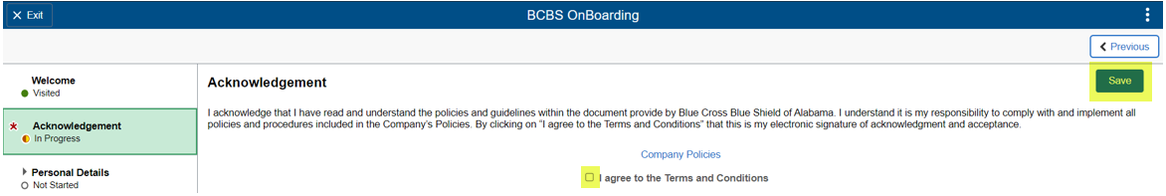  
  
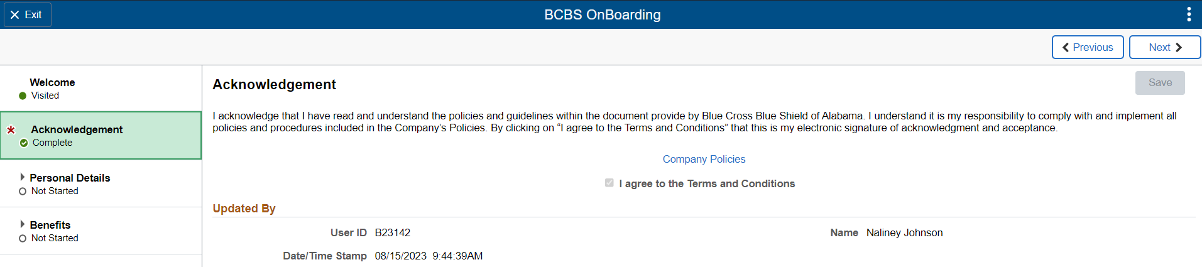

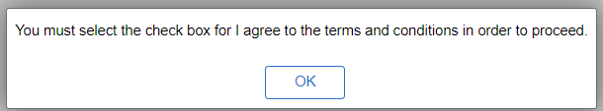 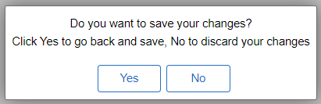

1. **Personal Details**

This consist of 6 subsections: Name, Contact Details, Marital Status, Addresses, Emergency Contact, and Additional Information. Most information under Personal Details only needs to be verified from what was pulled over from their application, however edits can be made to any field by clicking on the arrows. The two fields that will require new inforamtion is Marital Status and Emergency Contact.

* 1. Name
     + This was pulled over from the application but they can edit this by clicking on the arrow.   
       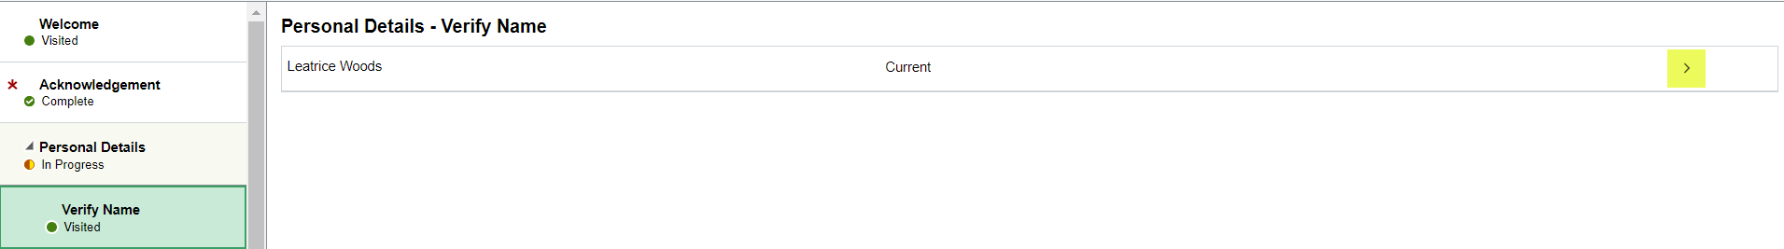  
          
       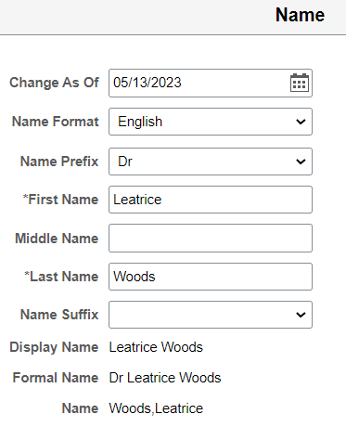 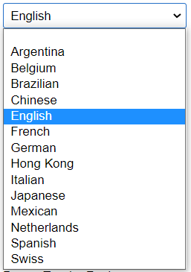 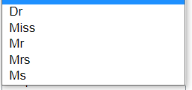 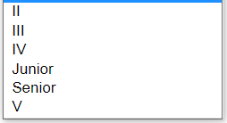
  2. Contact Details
     + This information was pulled from the application but edits can be made by clicking on the arrow. If additional information needs to be added then they will click on the “+” button.   
       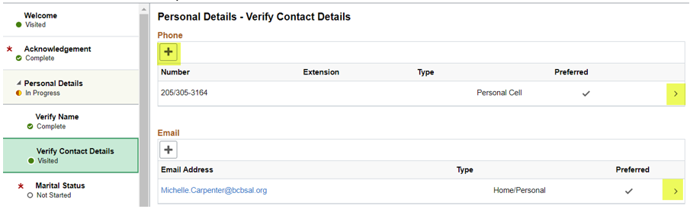

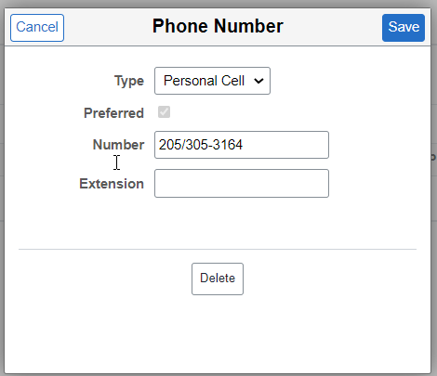 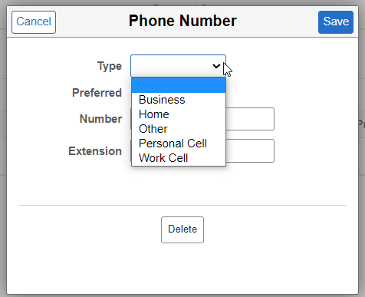

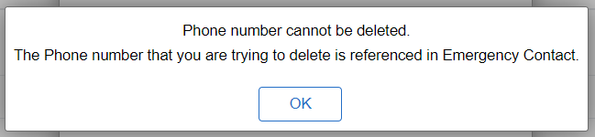 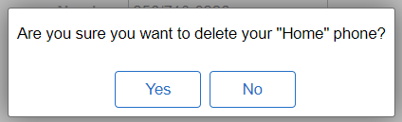

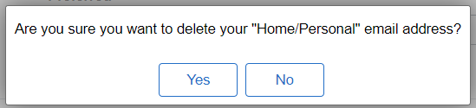 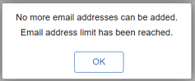

* Only one email address is allowed

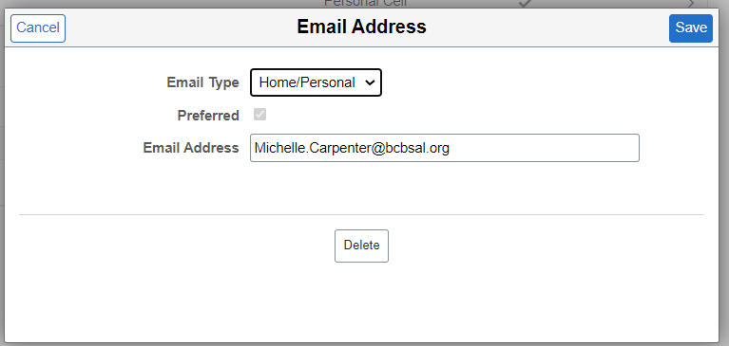 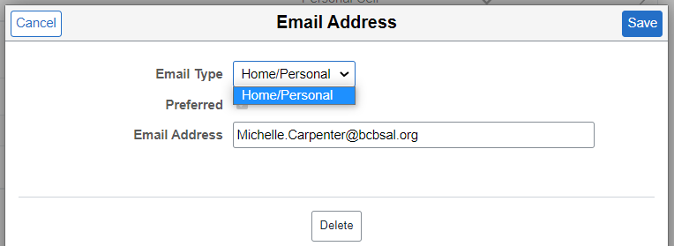

* 1. Marital Status   
     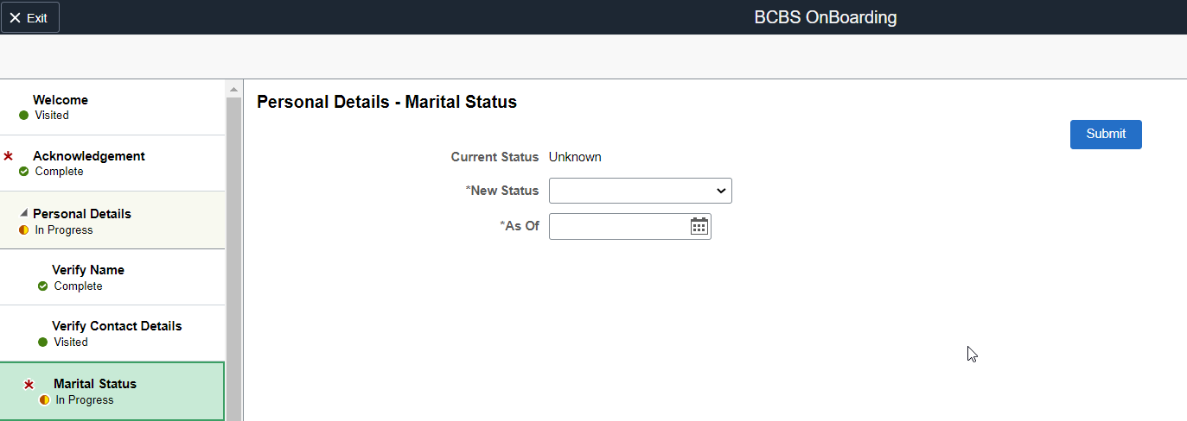

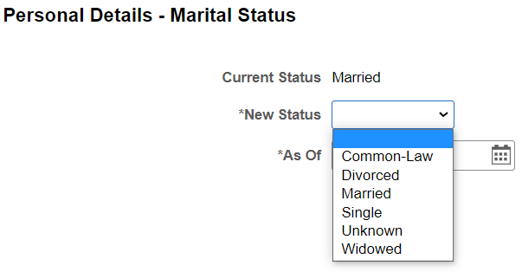 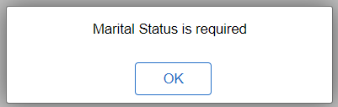

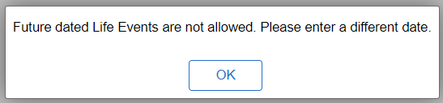 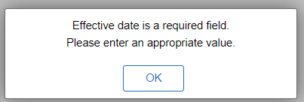

* 1. Verify Address
* This information was pulled over from the application. If they want to edit it, then click on the arrow.  
  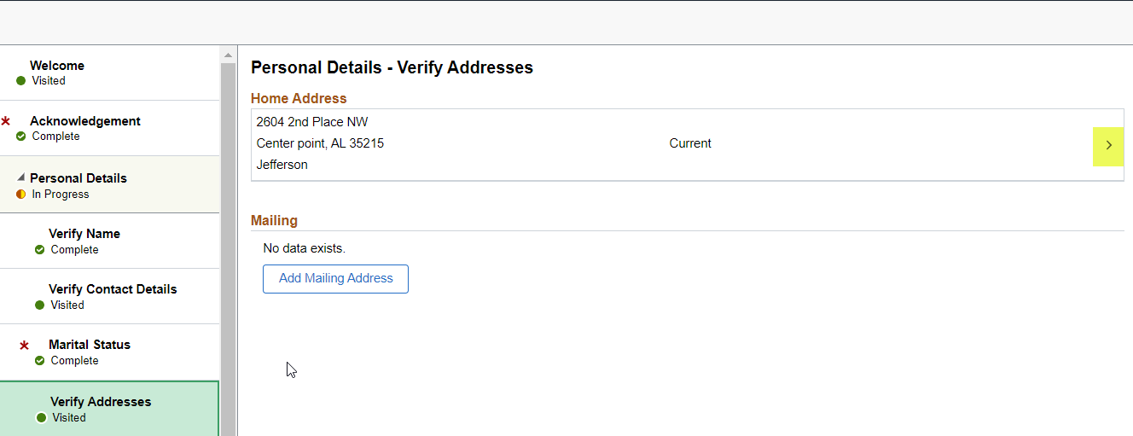

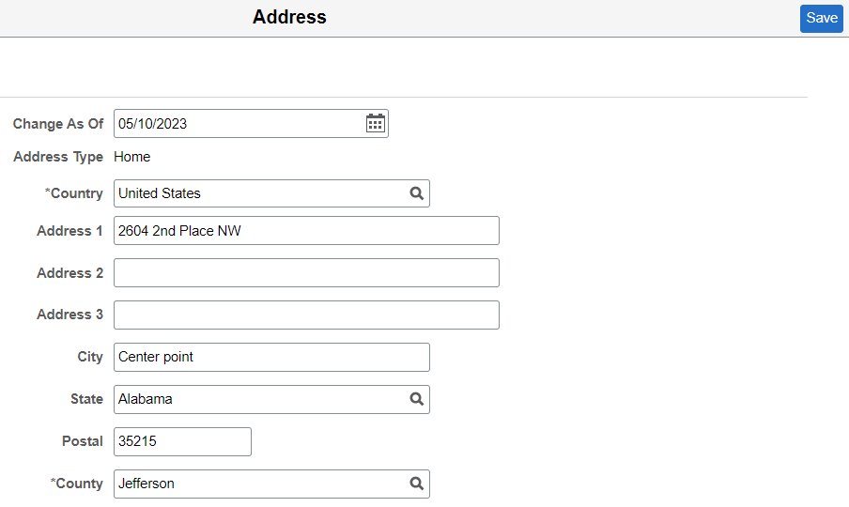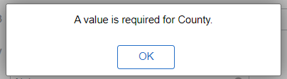

* They have the option to add a mailing address but it is not required. They also can add a future dated mailing address.

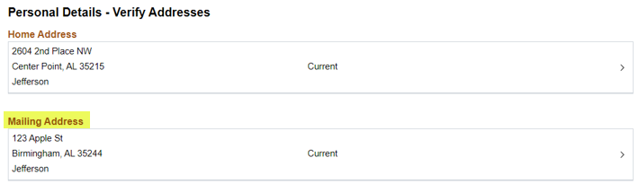

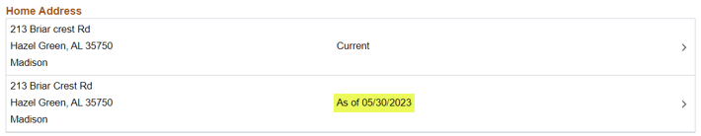

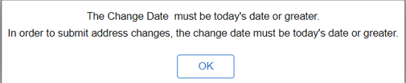

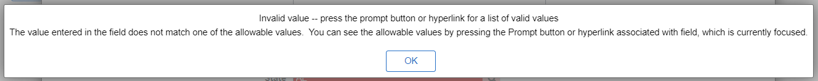

* 1. Emergency Contact   
     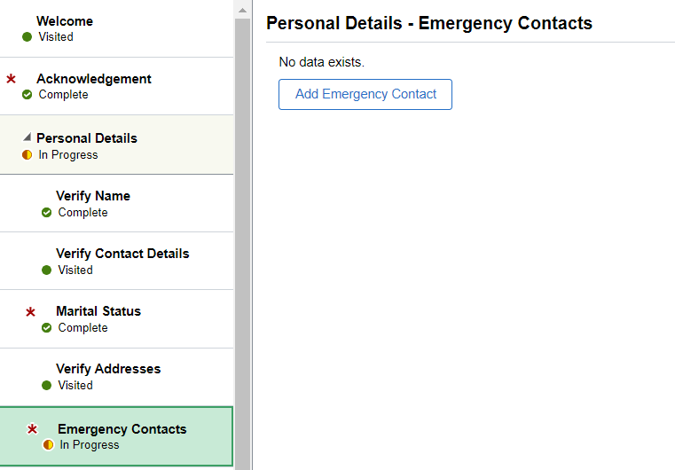

The emergency contact bubble will remain “In Progress” until manually overridden at the end of Onboarding.

* + - The employee can edit the existing information by clicking on the arrow or can add additional contacts by clicking on the “+” button  
      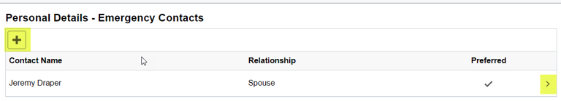

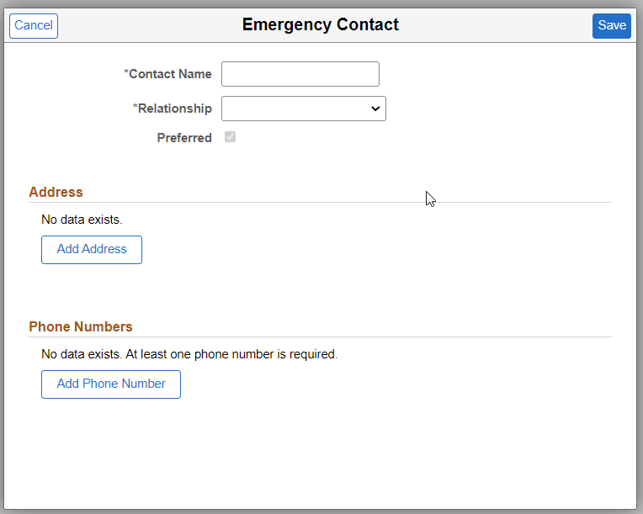 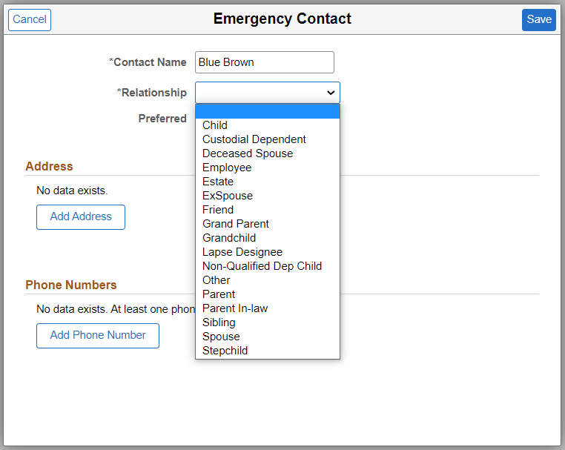  
  
  
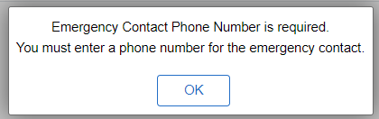 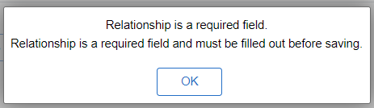

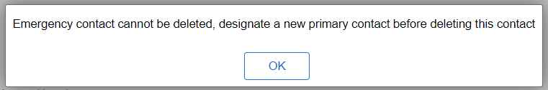 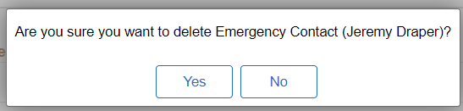

* 1. Additional Information
     + If changes need to be made to anything under Additional Information please send, corrections to Michelle Carpenter.   
       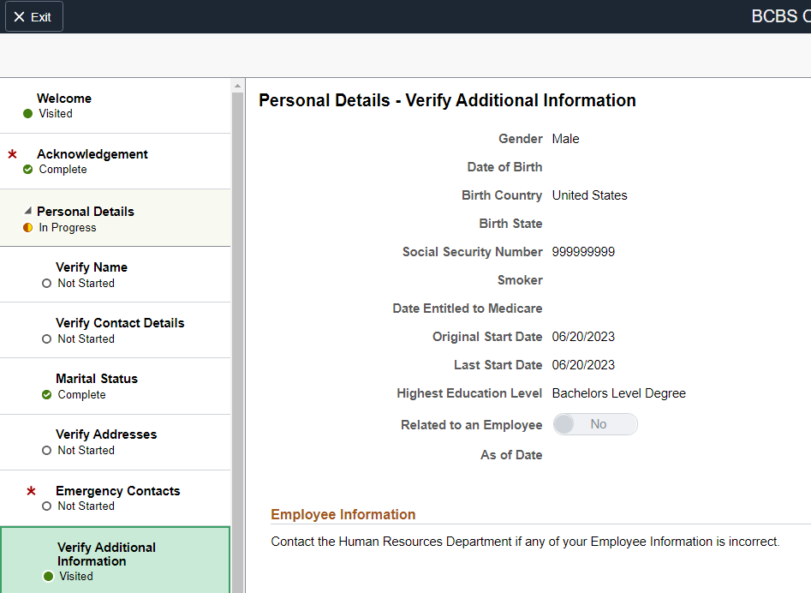

1. **Benefit Enrollment**   
   Electing benefits is to be completed the day of orientaion and if changes are needed up until 30 days from their start date, the employee will need to email Michelle Caprenter to those changes to be made. Depending on the employee’s position they may or may not have benefits offered.

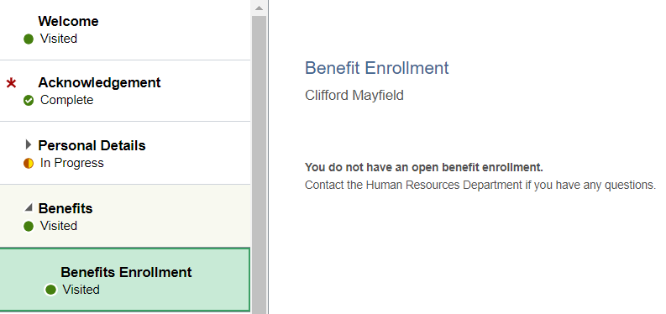   
  
  
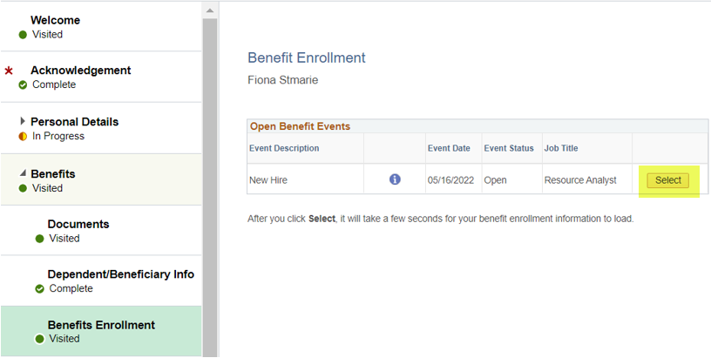  
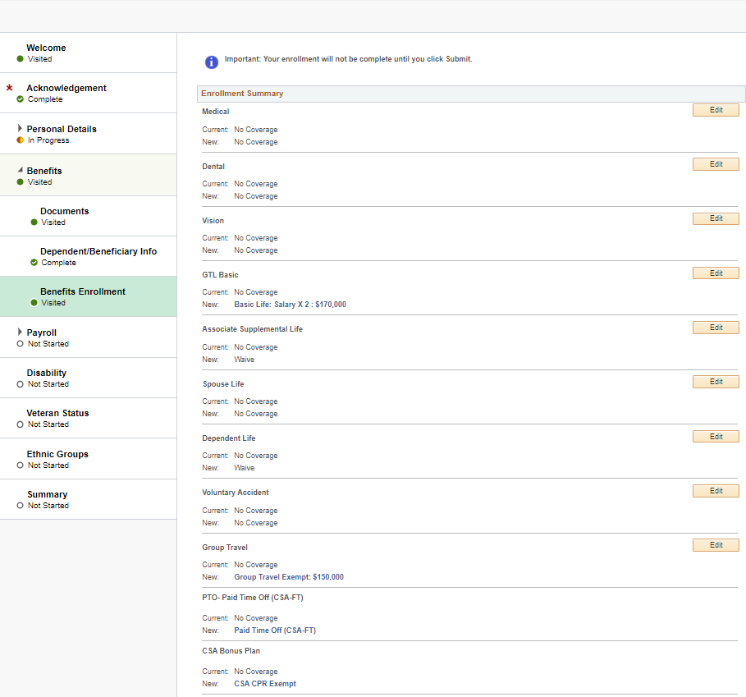  
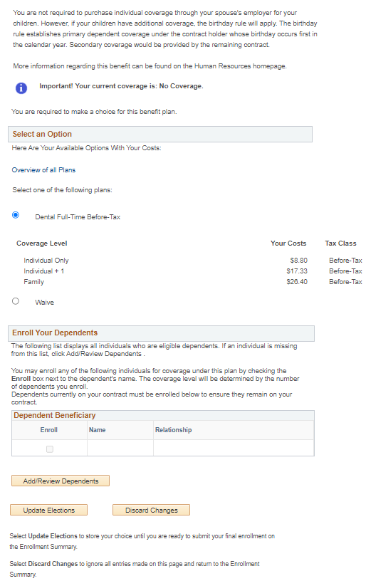

Employee with benefits

Employee without benefits

GTL Basic and Group Travel must have beneficiaries listed.

Every benefit listed must be visited by clicking on the “Edit” button. Each benefit needs either to be waived or enrolled in.

If a family plan is desired, click the full-time before tax bubble then click “Add/Review Dependents”.

**We must have DOB and SSN for spouse and children.**

If an individual plan is desired, click the full-time before tax bubble and click update elections.

1. **Payroll**  
   Payroll has two sections W2 Consent and Direct Deposit.
   1. W2 Consent  
      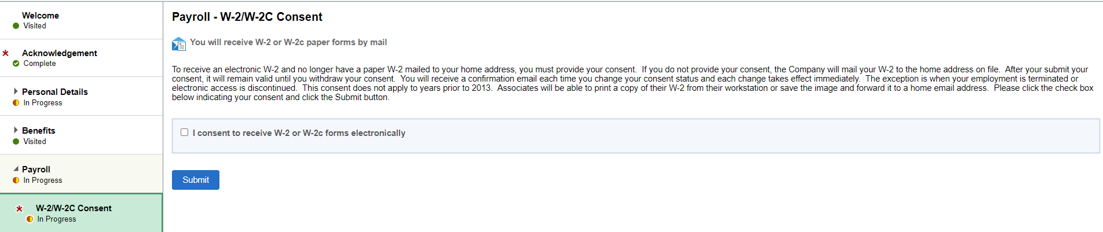  
      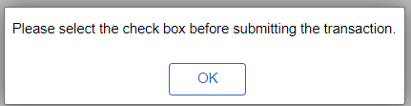 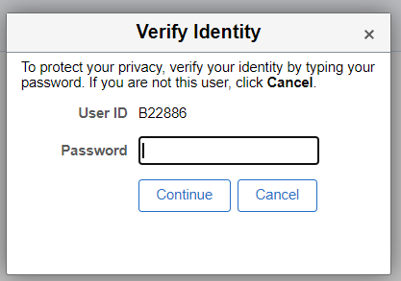 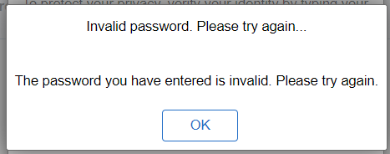



* 1. Direct Deposit
     + One or multiple accounts can be added. If it’s only one account have them select “Remaining Balance”   
       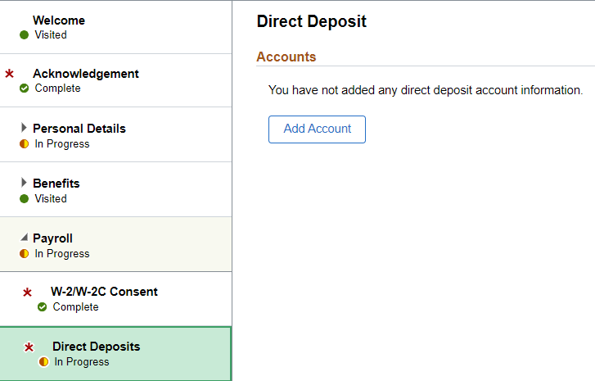 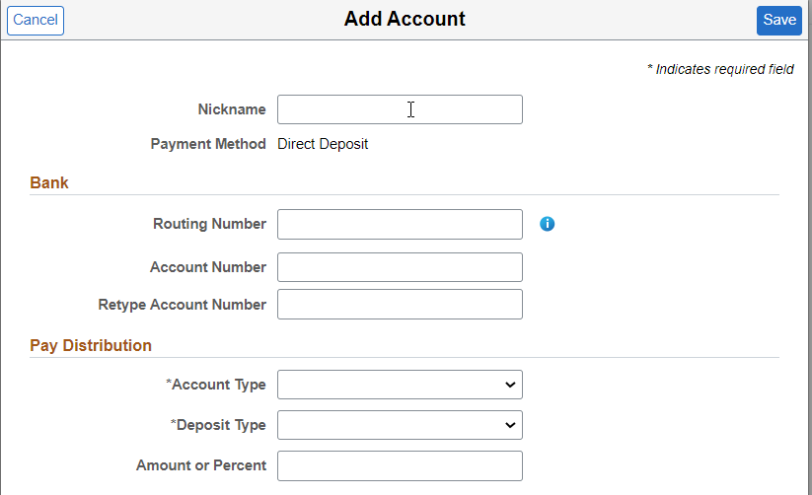

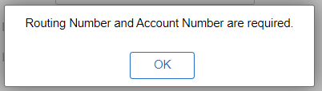 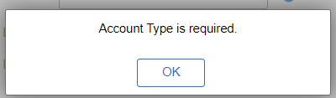 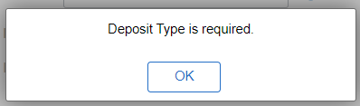

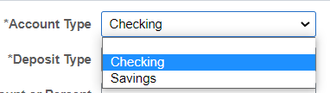 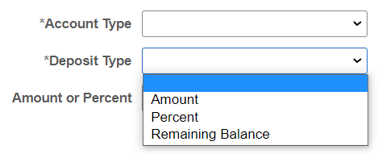 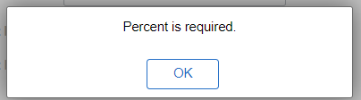  
  
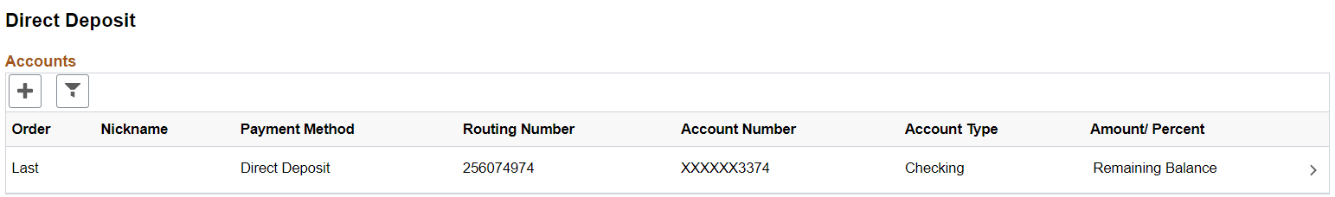

1. **Disability**   
   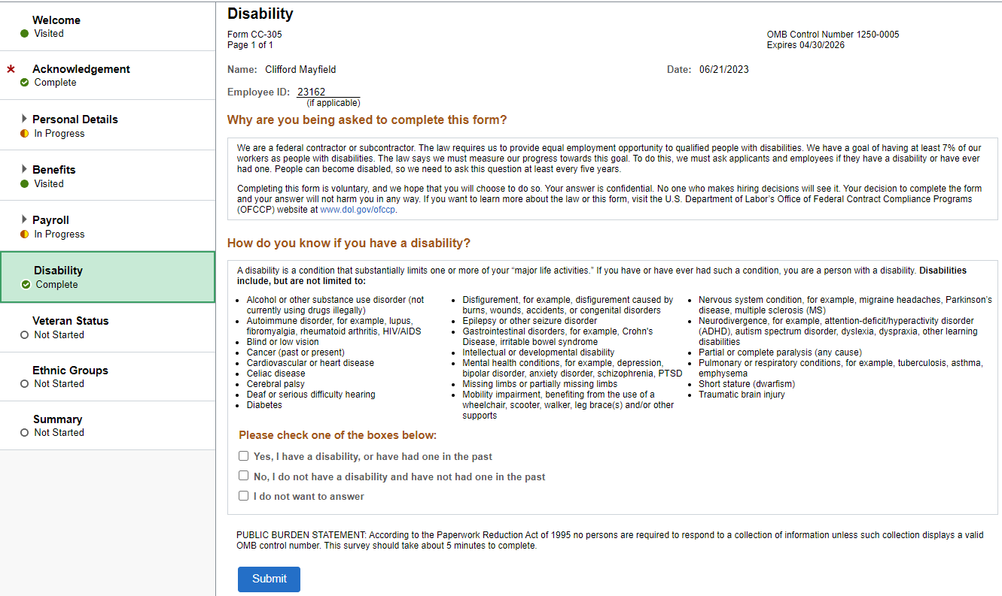  
     
   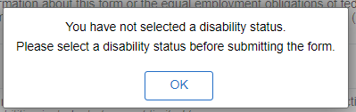
2. **Veteran Status**  
   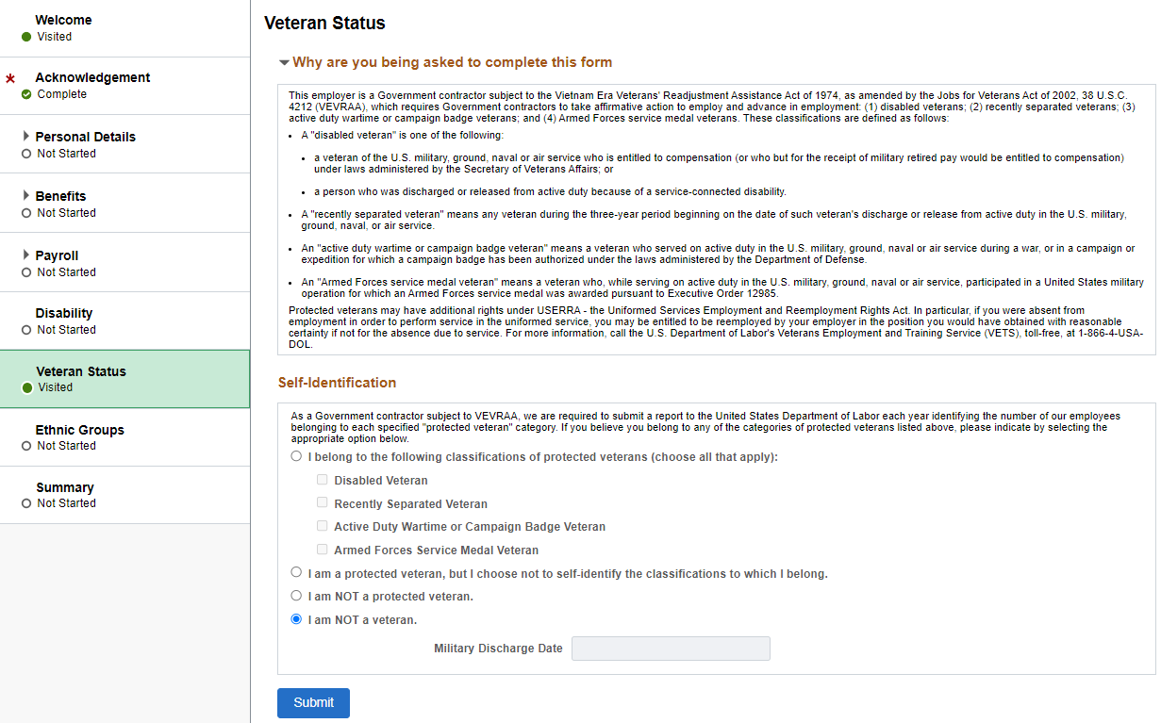

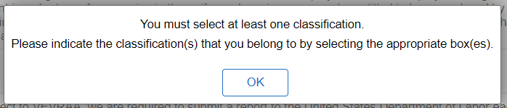 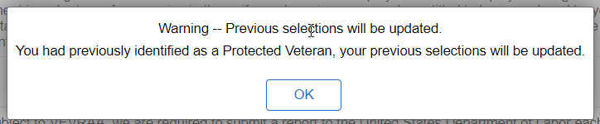

1. **Ethnic Groups** 
   * + This information should have pulled from pre-boarding but can be edited or deleted by clicking on the arrows or “+” button.  
       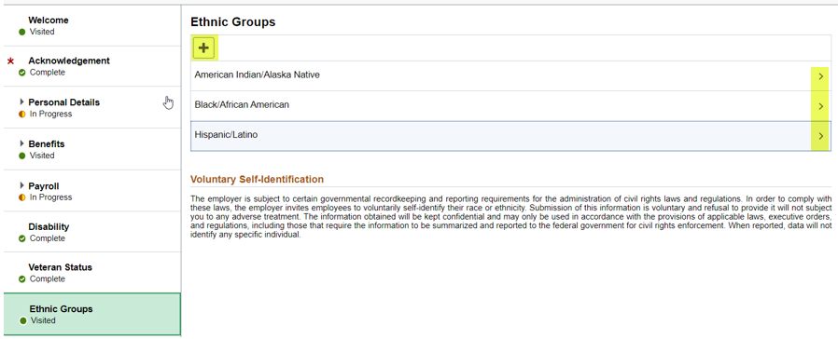
     + If the information did not pull then they can simply add it now.   
         
       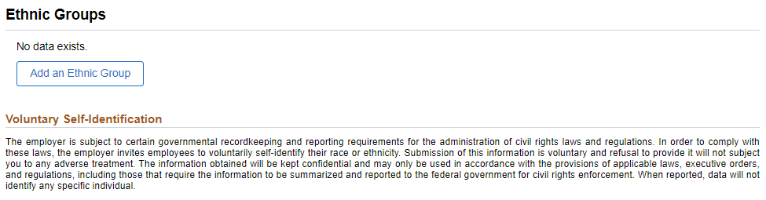

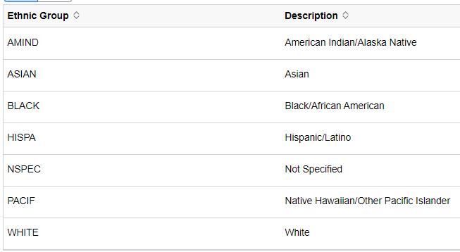

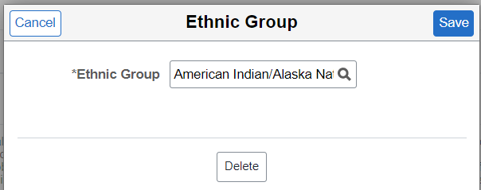   
  
  
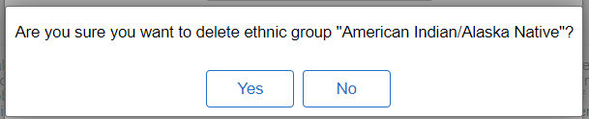

1. **Summary** 
   * + The summary page shows the steps completed, ones needing to be complete and required fields. The emergency contact and direct deposit must be manually marked as completed before onboarding can be complete.

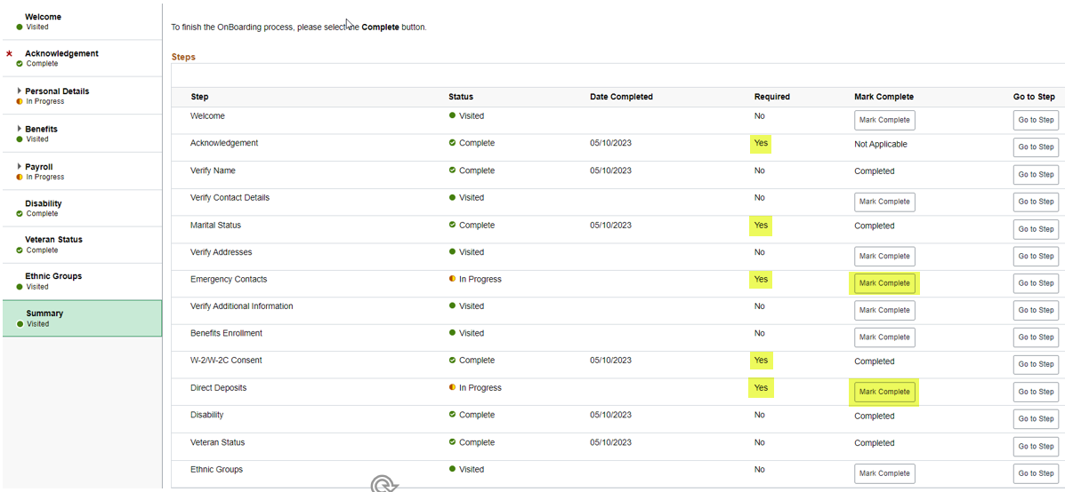

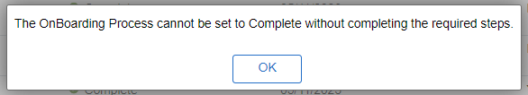

* Once all fields are complete the blue “Complete” button will appear. Click on that button and Onboarding is complete.

